# Workshop: Personal Portfolio

The workshop is part of the ["JavaScript For Front-End Course@SoftUni"](https://softuni.bg/trainings/2032/javascript-for-front-end-july-2018#lesson-8965).

# Getting started with Bootstrap

It’s time to create your first personal portfolio based on Bootsrap. First of all you should download the library from official [website](https://getbootstrap.com/). After that it’s time to create your initial page.

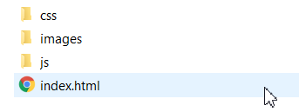

You should include all bootstrap files that you downloaded.

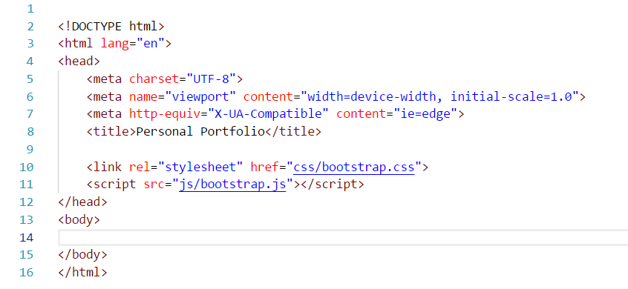

# Theming Bootstrap

For our portfolio we can use free Bootstrap theme from [Bootswatch](https://bootswatch.com/). The theme that we will use in this workshop is [Minty](https://bootswatch.com/minty/), but you can use another one if you want. Simply download a CSS file and replace the one in Bootstrap. That’s all we need to use the theme. Now it’s time to look our page design. You have resources (screenshots, images) in your resource folder. You don’t need text because you can design this portfolio like yours.

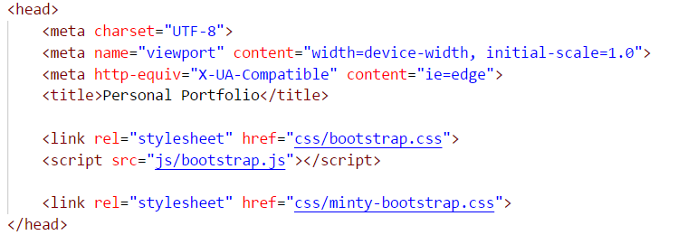

# Create Portfolio Page with Bootstrap

First of all we will need navigation bar. When we look at theme documentation we can see what kind of components she offer to us.

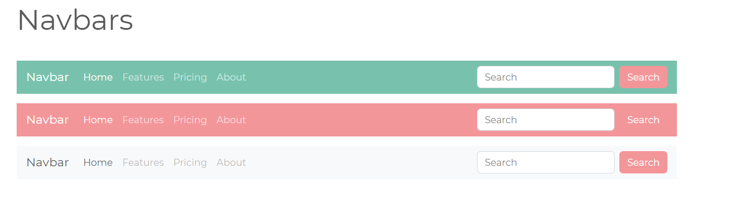

Well, our is kind of similar but it will need little changes.



Our first section is About. So in our theme documentation we can see how we can create container and after that we just need to center it and to change the content inside.

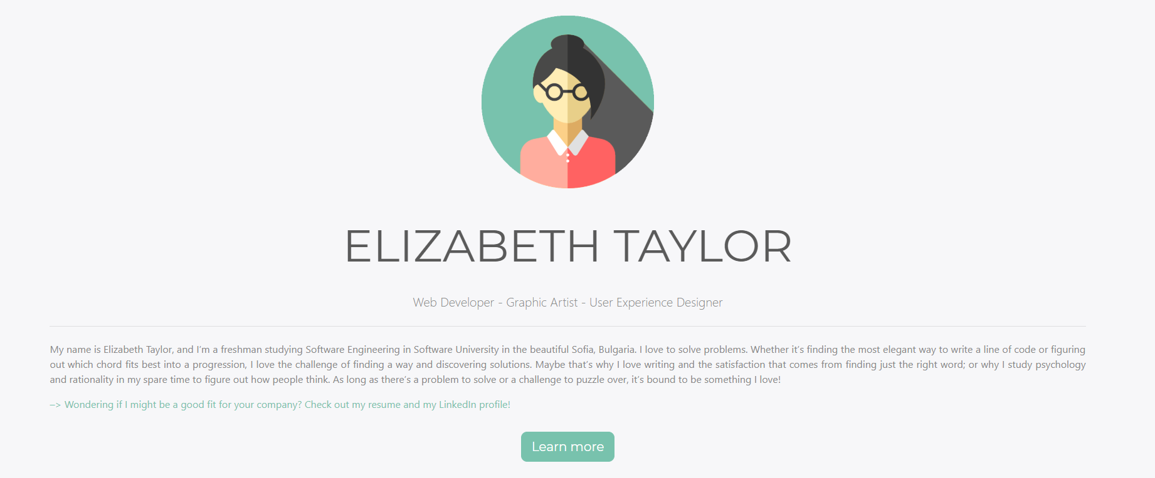

Experience and Skills sections looks similar too. So we can import some cards and progress bar templates and add little more content inside again.

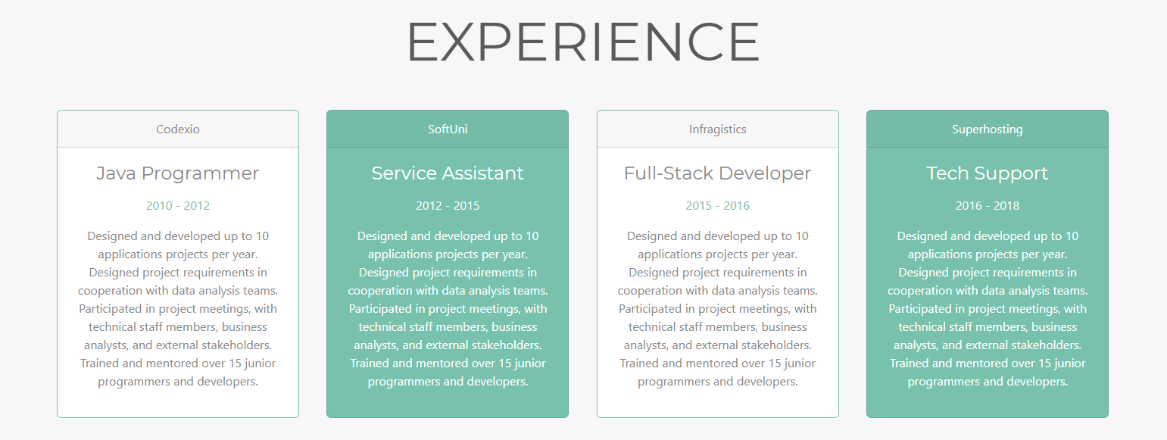

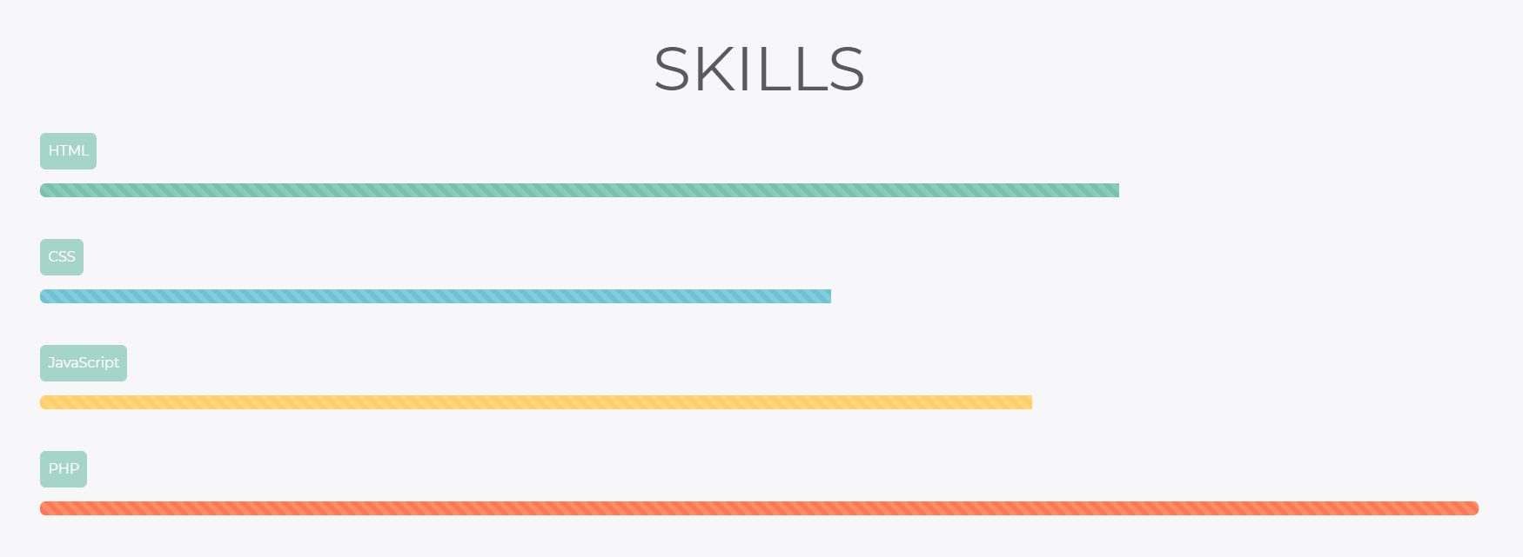

# Include some Bootstrap plugins

So now the easy job is done and we should import some custom bootstrap plugins in our portfolio.

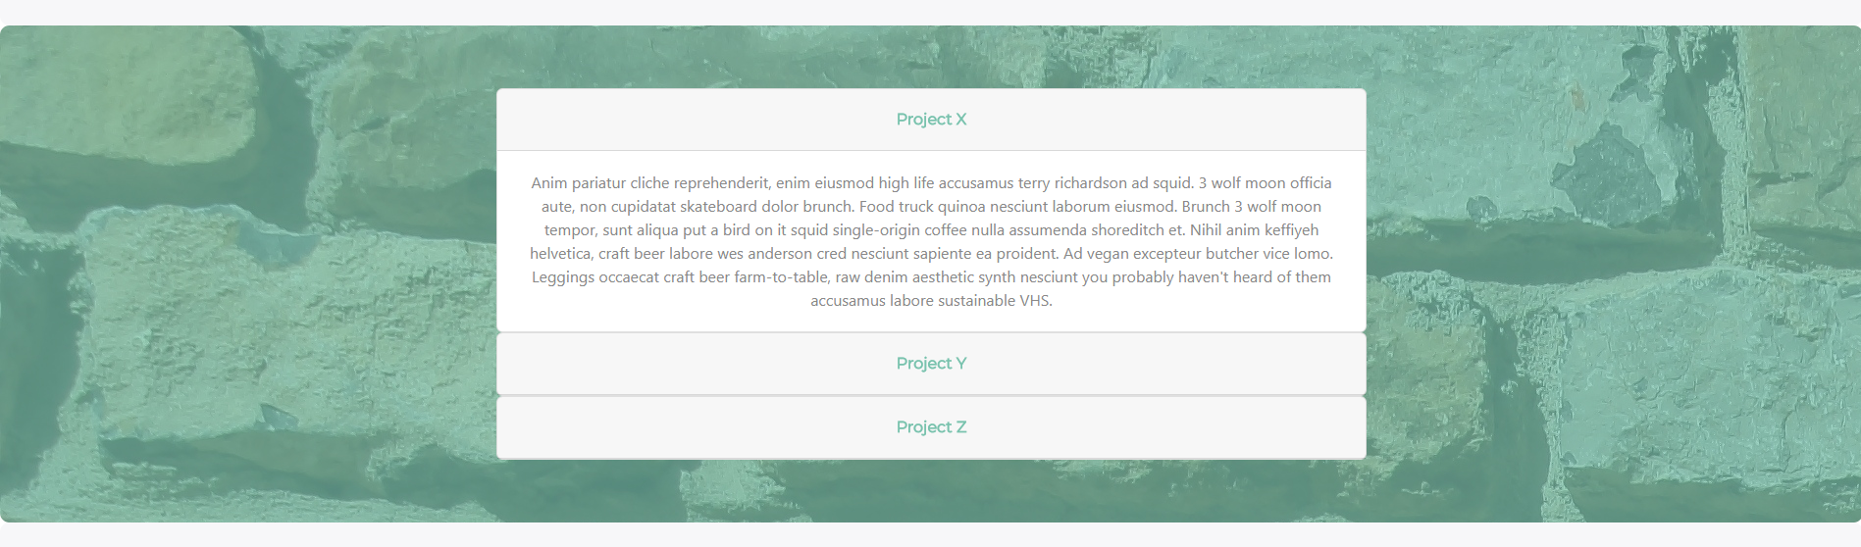

In Projects section we can use collapse component. You can read more about it in Bootsrap official documentation -

<https://getbootstrap.com/docs/4.0/components/collapse/>. But we will need to import our bootstrap.bundle.js file and [jQuery](https://jquery.com/) library in the head of the document.

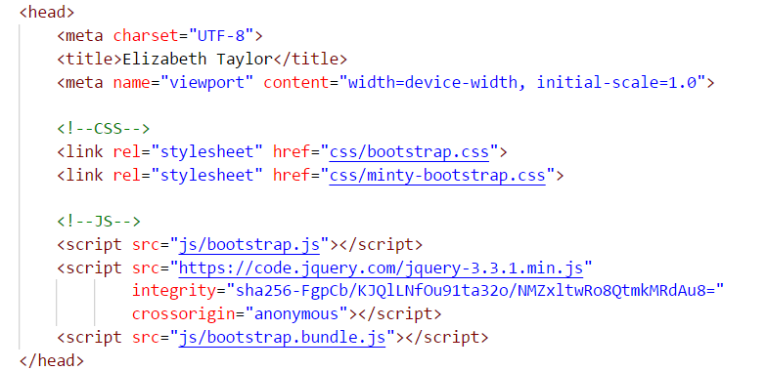

In Contact section we need to implement one little form which we can reuse from theme documentation.

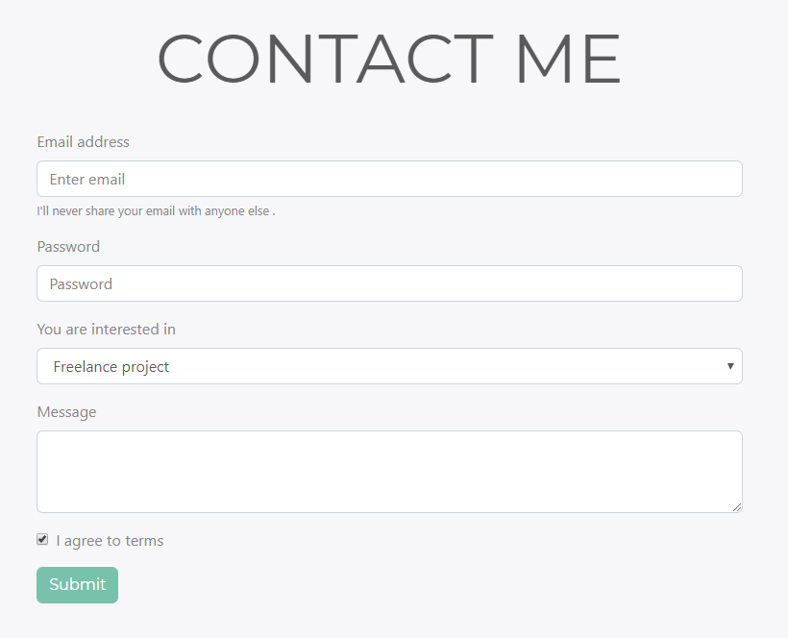 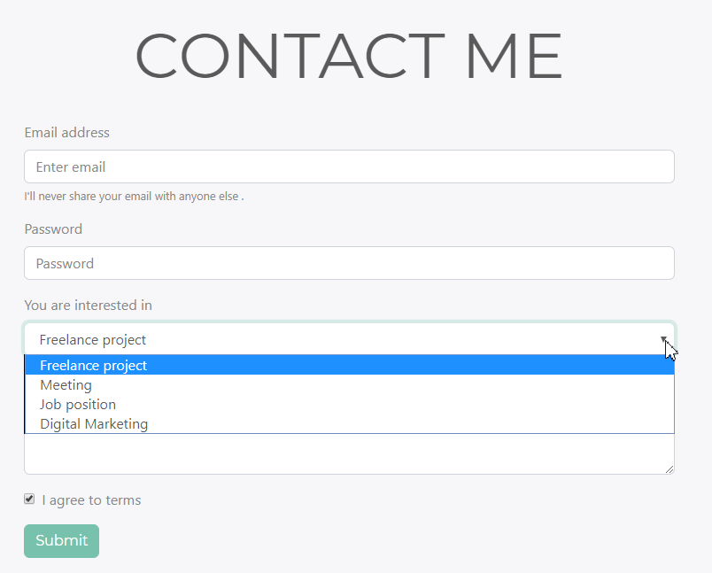

# Favicon

To have fully completed portfolio site you should not forget to add your favicon. You can use [favicon generator](https://realfavicongenerator.net/) online and upload some of your photos there.

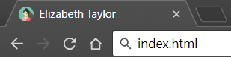

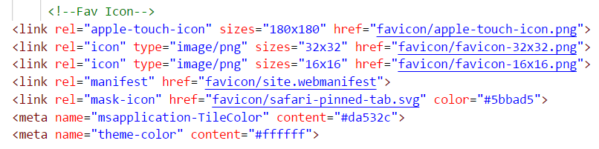

# Font Awesome

Our footer is quite simple. We just need to add a font and icon toolkit based on CSS and LESS. And guess which one is [that](https://fontawesome.com/).

